Ideation Phase
Brainstorm & Idea Prioritization Template

Date | 15 feb 2025
Team ID | LTVIP2026TMIDS42655
Project Name | Exploratory Analysis of Rainfall Data in India for Agriculture
Maximum Marks | 4 Marks

Brainstorm & Idea Prioritization Template:
Brainstorming provides a free and open environment that encourages everyone within a team to participate in the creative thinking process that leads to problem solving. Prioritizing volume over value, out-of-the-box ideas are welcome and built upon, and all participants are encouraged to collaborate, helping each other develop a rich amount of creative solutions.
Step-1: Team Gathering, Collaboration and Select the Problem Statement

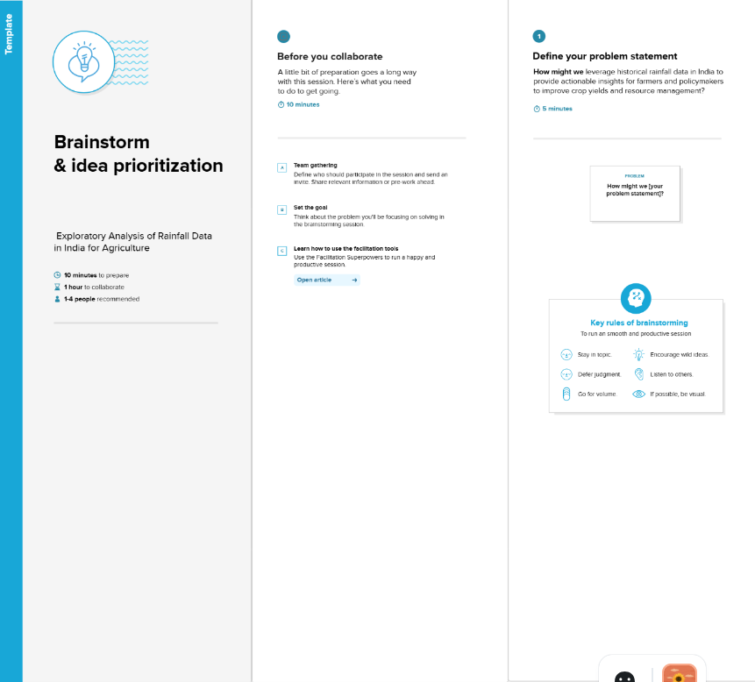

Step-2: Brainstorm, Idea Listing and Grouping
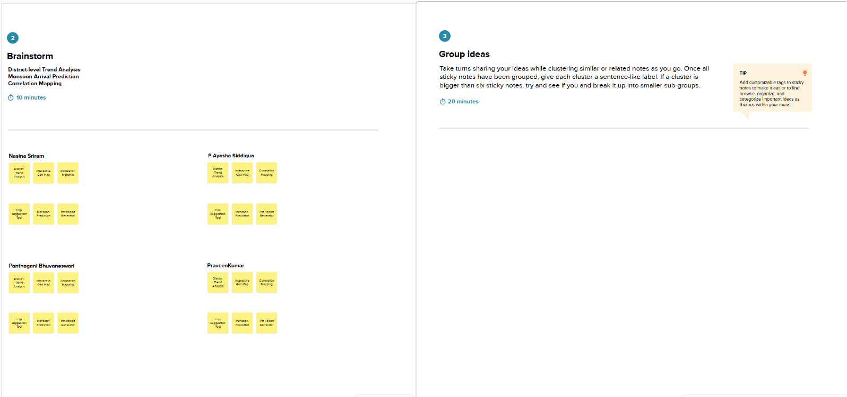

Step-3: Idea Prioritization


